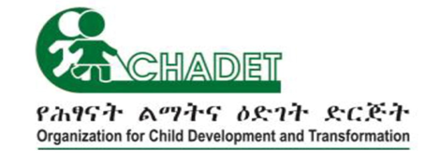

Girls Education Challenge – Transition: excelling against the odds
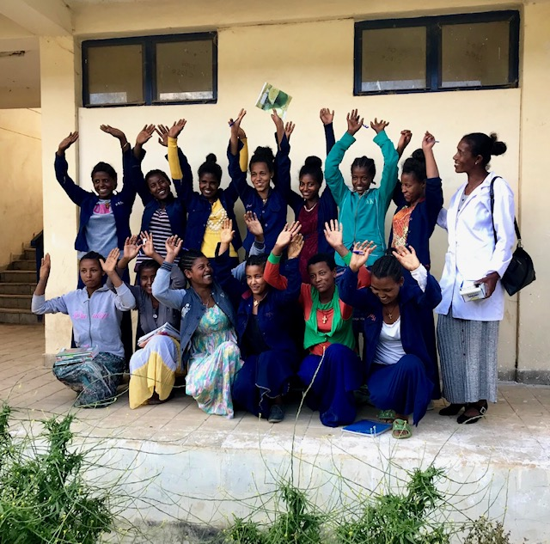
(April 2017 – March 2021)

SUMMARY OF KEY ACHIEVEMENTS

Organization for Child Development and Transformation (CHADET) is an indigenous non-governmental organization that works to improve the lives of marginalized children in Ethiopia by providing access to quality education and improving livelihood opportunities.
CHADET, in partnership with ChildHope UK has implemented the Girls’ Education Challenge Project (GEC-T) in two rounds. Round one (2014-2017) and Round two (2017-2021) in 74 rural school of Amhara and Oromiya regional states. The project was funded by UK- aid and managed by PWC, the second largest professional service network in the world.
The project entitled ‘Girls Education Challenge – Transition: excelling against the odds’ was aimed at supporting 16,481 girls to get quality education by removing barriers that girls face in their transition to secondary and higher levels of education. The support that was obtained from Bureaus of Education and Finance and Economic Development of Oromiya and Amhara Regional National States, school principals, teachers, communities and other stakeholders was instrumental for the success of the project.

Achievements in program delivery

 | 16,481 girls targeted  7,832 (South Gondar)  4,789 (South Wollo)  3,860 (Arsi) |  | 47 Primary and 27 Secondary Schools supported  In South Gondar: 22 Primary  11 Secondary  In South Wollo: 14 Primary  10 Secondary  In Arsi: 11 Primary  6 Secondary

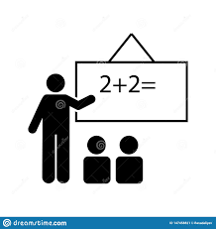 | 492 teachers were provided training on:  - Student centered, gender sensitive and inclusive pedagogy  - Revision techniques  - Provision of psychosocial support  - 261 - South Gondor  - 140 - South Wollo  - 91 - Arsi

 | 74 Reading corners established and stoked with books  33 - South Gondor  24 - South Wollo  17 - Arsi |  | - Sanitary  Corners established  33 - South Gondor  24 - South Wollo  17 - Arsi

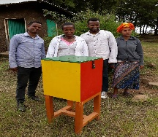 | 74 Letter link boxes set-up in 77 Primary and Secondary Schools for reporting safeguarding issues  33 - South Gondor  24 - South Wollo  17 - Arsi | 30 Letter link boxes for reporting safeguarding issues established in 30 Kebele administrations  15 - South Gondar  9 - South Wollo  6 - Arsi

 | Girls’ clubs and good brothers’ clubs established in 47 Primary Schools  27 girls’ forum established in Secondary Schools | 121 focal teachers trained in safeguarding, life skill, Social inclusion, case management supported the girls and the good brother clubs

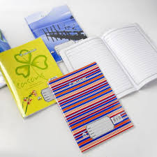 | 16,481 girls received scholastic materials such as exercise books, pens, pencils and mathematical sets.  7,832 - South Gondor  4,789 - South Wollo  3,860 - Arsi | 7,500 girls received uniform  3,500 - South Gondor  2,000 - Arsi  2,000 - South Wollo

1,251 girls have a received transition cost
600 - South Gondar
363 - South Wollo
288 - Arsi

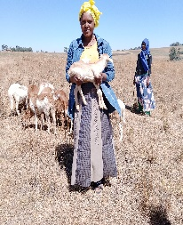 | 98 girls who have undergone through TVETs have benefited from Income Generation Activities (IGA)  36 - South Gondar  36 - South Wollo  26 - Arsi | 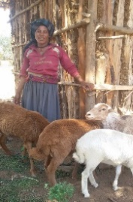 | 100 mothers/care givers of the target girls have benefited from the IGA programs  40 - South Gondar  30 - South Wollo  30 - Arsi

 | 133 School principals and vice principals received training in school leadership, provision of psychosocial support and overall management  57 - South Gondar  45 - South Wollo  31 - Arsi | 109 community of practice established for encouraging peer to peer support among teachers  62 - South Gondar  30 – South Wollo  17 - Arsi

 | 82 Committed volunteers participated in the project to support girls and their communities  31 - South Gondar  29 - South Wollo  22 - Arsi
Output level achievements

- Safer and stimulating learning spaces for girls created
98% girls reported that they feel safe in school
86% girls reported they feel safe outside school due to the buddy system the project created
- Transition costs of girls covered
1,251 girls transitioning to high school received bursaries

- Well trained teachers supported girls thrive in learning
492 teachers trained in student centred pedagogy and helped girls achieve high in literacy and numeracy (see learning results below)

- Empowered girls challenged negative social norms

- Livelihood option created for girls and mothers/care givers of project participants

Outcome level achievements

- LEARNING
- Numeracy

- Literacy: The project has significantly impacted on literacy outcome

- TRANSITION
Transition rate is 96%

- ATTENDANCE

- TEACHER QUALITY
- 46.8% of lessons in the treatment group demonstrated improved preparation, compared to 28.8% of lessons in the control group.
- 16.0% of lessons in the treatment group demonstrated improved pedagogy, compared to 5.5% of lessons in the control group.
- 38.3% of lessons in the treatment group had adopted improved assessment practices compared to 34.2% of lessons in the control group.
- SELF ESTEEM
- 90.2 % of girls demonstrated increased self-esteem which improved their learning outcomes
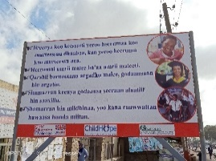
COVID 19 Response
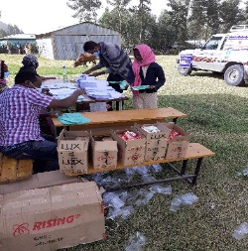 | - 37,616 bars of soap distributed to all girls in the project  - 5182 Sanitary pads were distributed  - 2,528 girls received ETB 300 as one-off support  - 12,292 girls received first round worksheets in Maths, English and local language  - 12,455 girls received second round worksheets  - 13,000 leaflet containing basic facts about COVID 19 were distributed for all the girls and their communities

